PUNE INSTITUTE OF COMPUTER TECHNOLOGY

(DHANKAWADI, PUNE-43)



MINI PROJECT REPORT ON

“KITCHEN ASSISTANT”

SUBMITTED BY

RITESH GHORSE (3931)

GAURAV DADLANEY (3926)

CHETAN CHAKU (3925)

CHAITRAJ METE (3923)

(Third Year Information Technology)

UNDER THE GUIDANCE OF

Prof. KAMLE

Submitted To

**Pune Institute of Computer Technology**

**For Academic Year 2017-18**

|  |  |
| --- | --- |
| **TITLE** | **PAGE NO** |
| **1. Introduction** | **3** |
| **2. Scope and limitations** | **4** |
| **3. Flow Diagram** | **5** |
| **4. E-R Diagram (description)** | **6** |
| **5. Normalization(up to 3NF)** | **7** |
| **5. Coding -Procedure and Triggers, view Design (description)** | **8** |
| **5. Coding design (snapshots)** | **9** |
| **6. User Interface Snapshots** | **13** |
| **7. Conclusion** | **29** |

*the above will be modified when the report is finalised.

# INTRODUCTION

KITCHEN ASSISTANT is a virtual cook book that will help you keep track of your ingredients and suggests delicious recipes based on those ingredients.  
In Kitchen Assistant you will save a lot of time by referring to recipes you customized to YOUR way of cooking.  
You can also use this application as a checklist you can quickly consult in shops while shopping for grocery and spices.  
Some sample recipes are embedded in order to show you how to better use this application.

*can we include the following statement?  
//With this lite version, you can backup you recipes online (upload and download). Downloading recipes created by other people is available in the full version.

# SCOPE

* Kitas is a versatile solution to all cooking related problems, a very good example to which is expanding its functionality for restaurant to manage its customized recipes.
* Customers can also use Kitas in selecting their preferences of recipes according to specific ingredients or type of food in restaurants.
* It can also be used as an inventory manager stand alone application as well.

For e.g:

Consider a restaurant with its head chef, say Monica, using Kitas application. Monica can easily divide her daily workload with Kitas in many ways, some of which can be listed below:

1. Monica’s daily routine starts with her listing down groceries and spices she would be needing, since she has updated the inventory on Kitas last night, she doesnt need to remember anything and doesn't have to worry about missing anything for the list either.
2. Now say, she has appointed a new chef to help her, being the head chef she cannot possibly teach him about her preference of cooking, instead, she decides to share her favorite recipes with him on Kitas, thereby saving her a ton of time.

On the other side of the coin, imagine a customer, say Ross. Ross has a tough time in restaurants due to his allergies to diary products and peanuts. He is tired of explaining his preferences every time he visits a new restaurant. Now lets see how with an outlet using Kitas can change this experience for him.

1. When Ross sits down to eat in the restaurant the waiter hands him a tablet with Kitas where he has an option of going through the recipes according to the ingredients specified by him. This makes ordering food for him not only convenient but also safe.
2. This is how both the customers and chef and use Kitas to make ordering and cooking easier.

# LIMITATIONS

1. Limited recipes are embedded in our application.
2. Pre-defined ingredients are also added in a finite number.

# MAIN MODULES OF KITAS

* Customers
* Recipes
* Ingredients-wise search
* Categories-wise search
* Ingredient Tracking

# E-R Design

# 

# SCHEMA DEFINITION:

# TABLE LIST:

Do we simply list down the table names or do we include their structures??

# CODING:

# PROCEDURES USED:

# *bakwas starts below.

# SAMPLE FORMAT:

1. Procedure for Calculating Average of voting And marks of contestants

create or replace procedure percentage(av IN number,votes IN number,percent out number)

is

begin

percent:=(((av/10)*50) + ((votes/50)*50));

end;

**CODING**

**Procedures and Triggers Used**:

1.Procedure for Calculating Average of voting And marks of contestants

create or replace procedure percentage(av IN number,votes IN number,percent out number)

is

begin

percent:=(((av/10)*50) + ((votes/50)*50));

end;

o/p- Procedure created.

2.Procedure for Calculating Votes for contestants

create or replace procedure votecount(codno IN number)

as

begin

update final_contestants1 set votes=votes+1 where code_no=codno;

end;

o/p- Procedure created.

3.Trigger for Eliminating Contestants

create or replace trigger trEliminations

after delete

on show2

for each row

begin

if deleting then

insert into eliminations values(:old.weekno,:old.code_no,:old.avg,:old.votes,:old.percent);

end if;

end;

4.Sequence

create sequence final_seq INCREMENT BY 1 start with 1;

# Coding Snapshot

( Atleast 3-4 forms)

# User Interface Snapshots

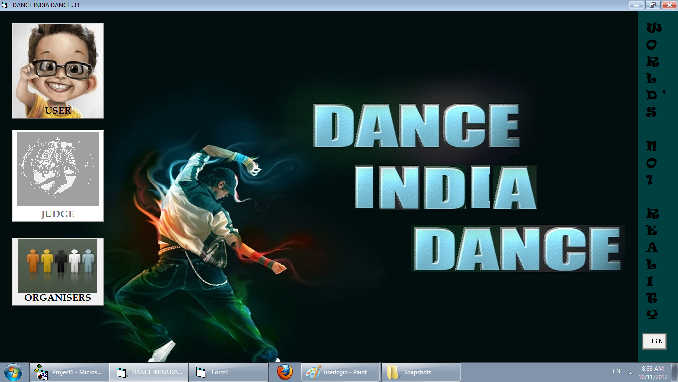

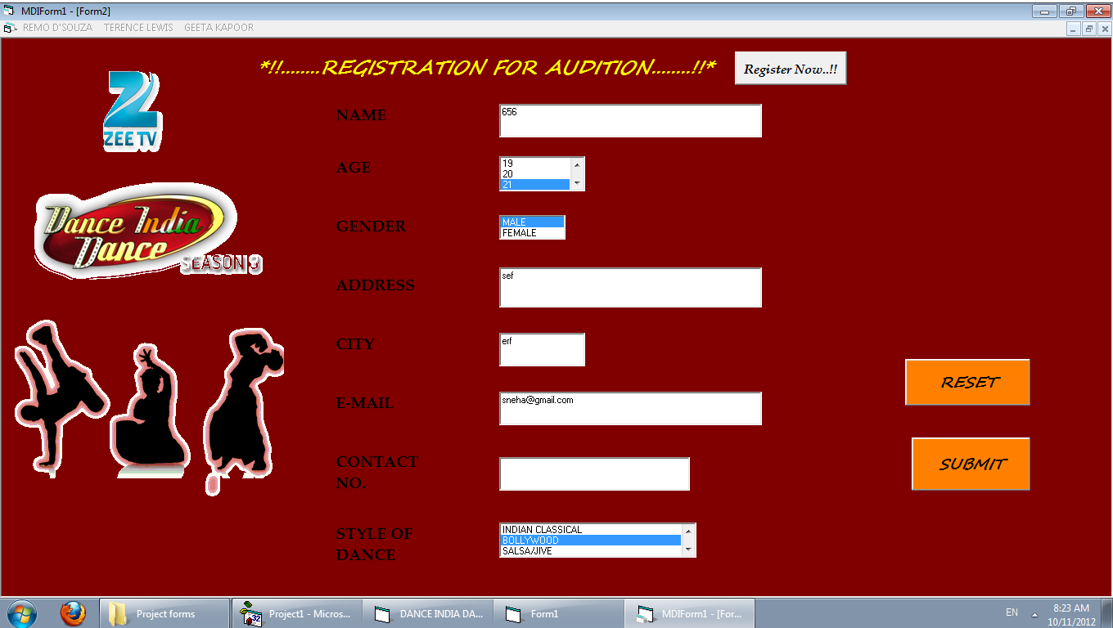

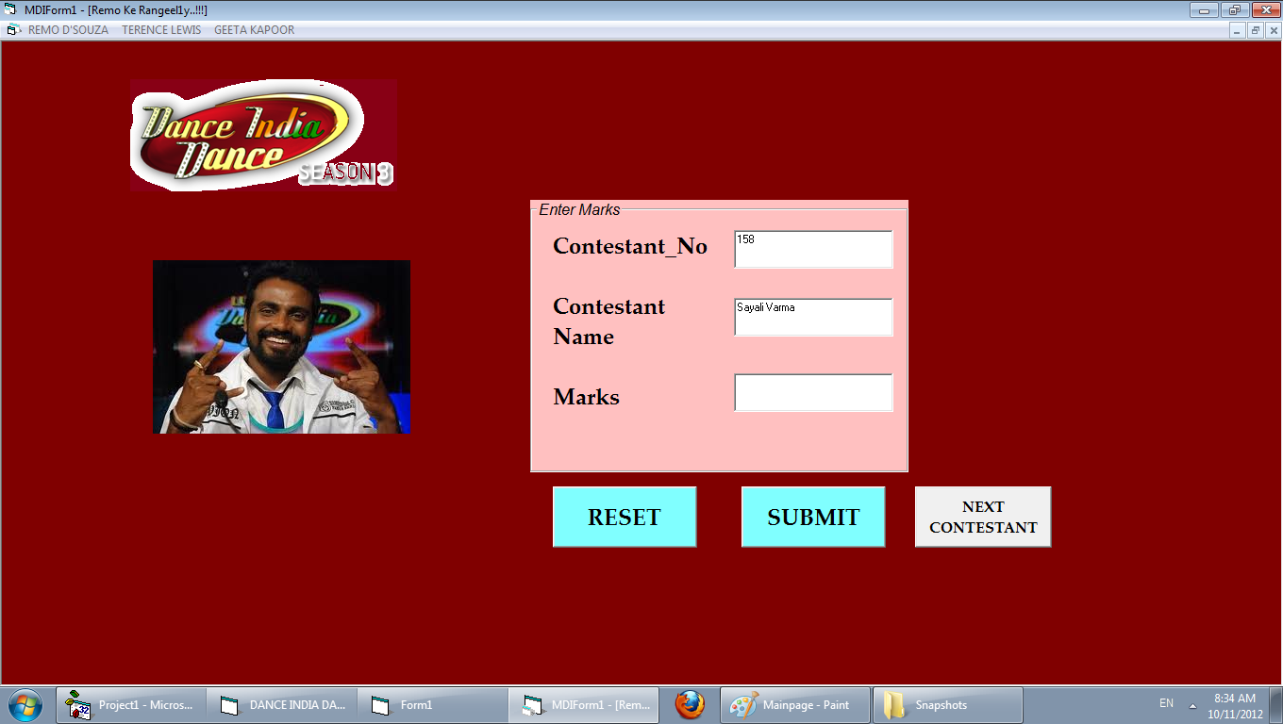

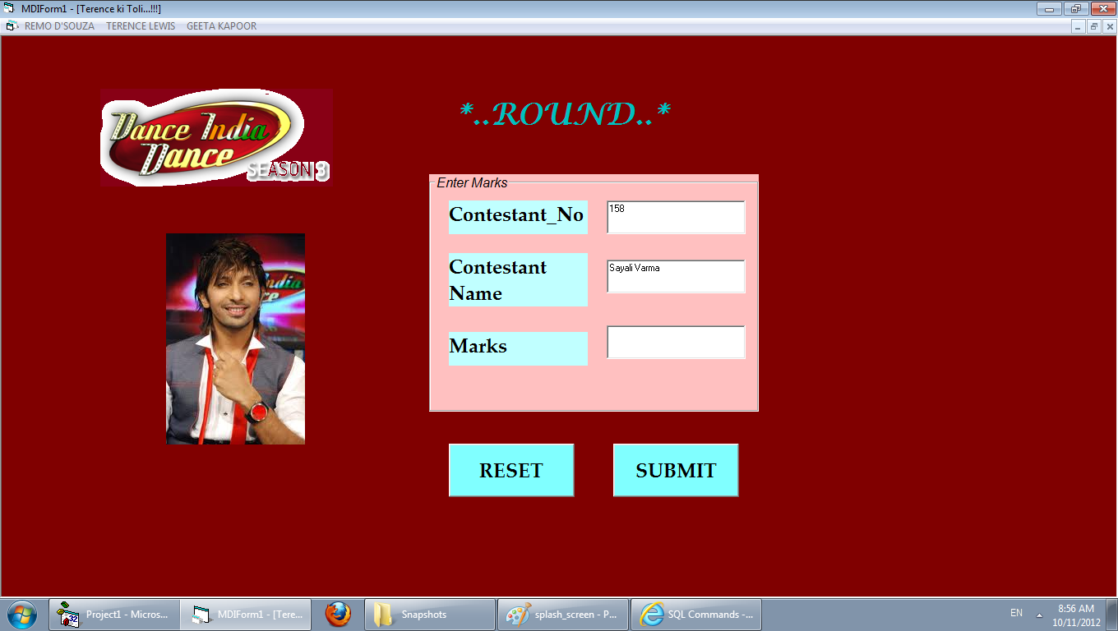

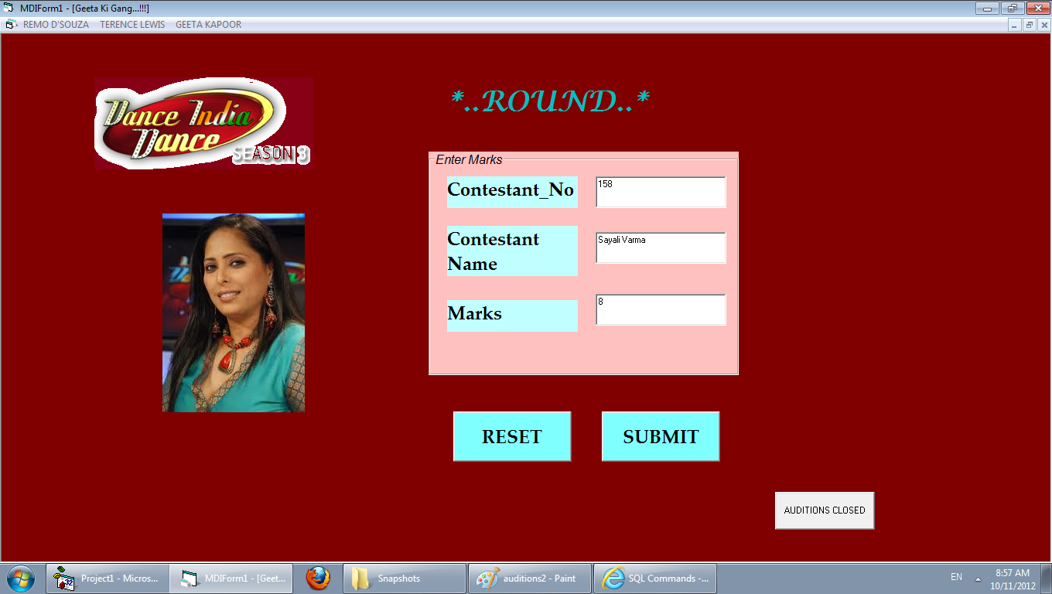

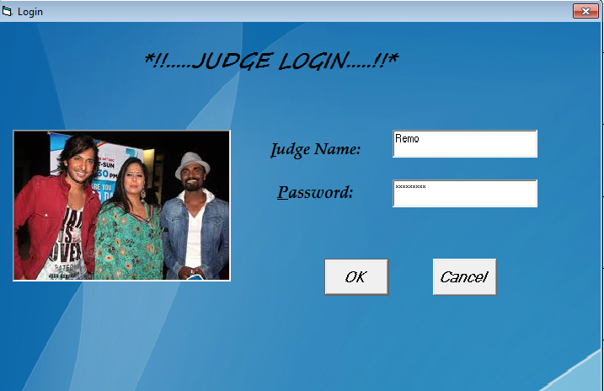



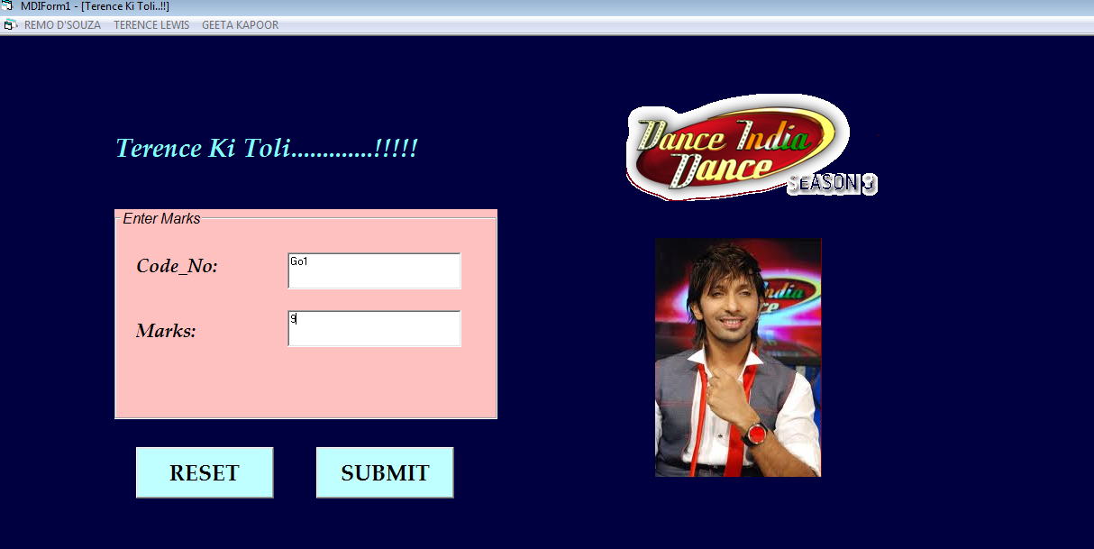

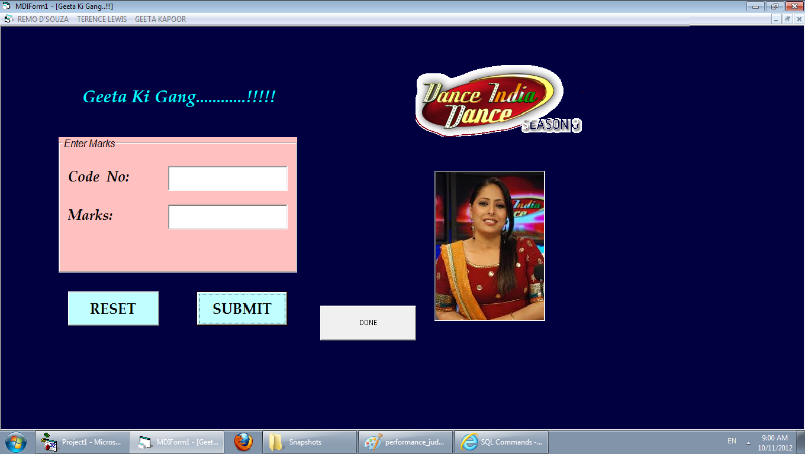

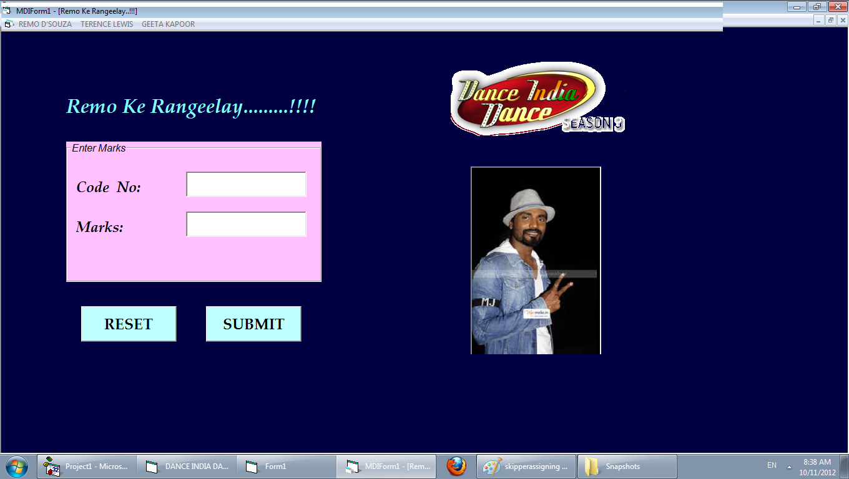

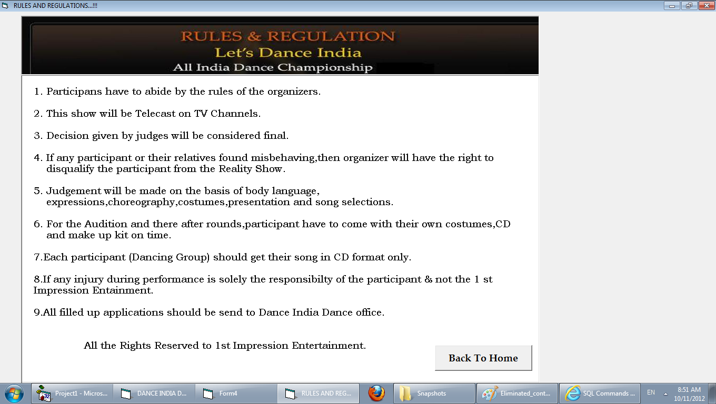

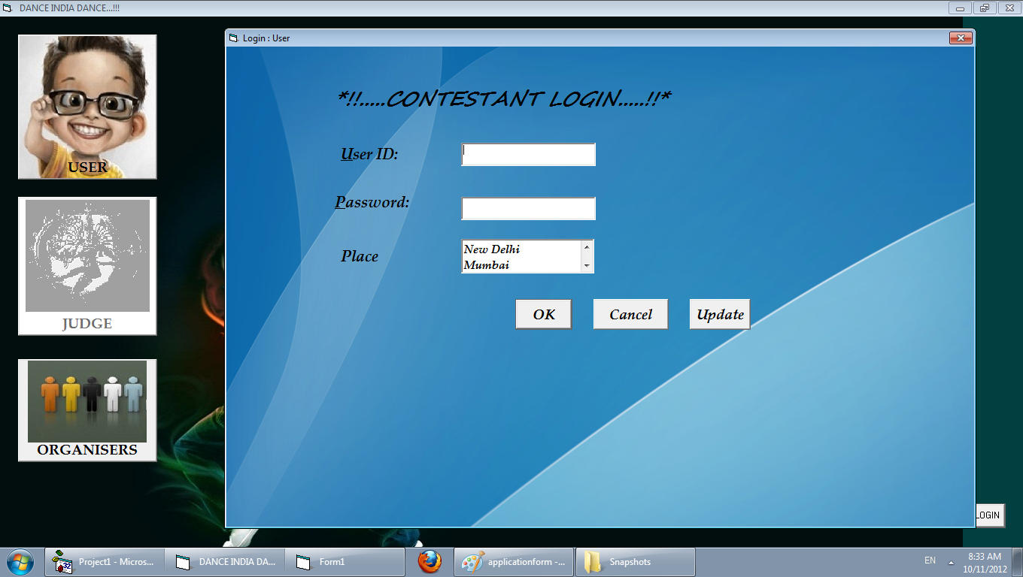

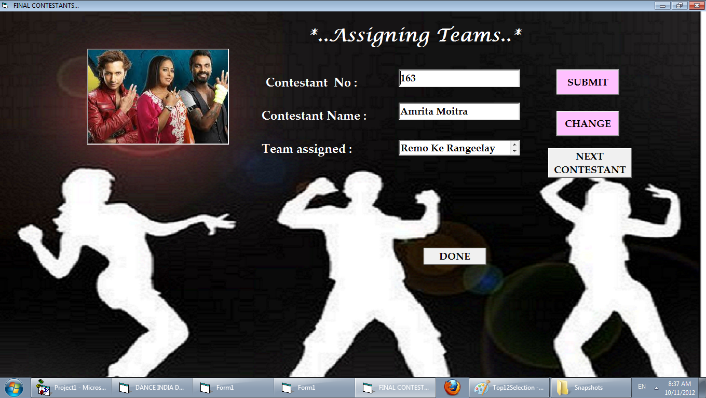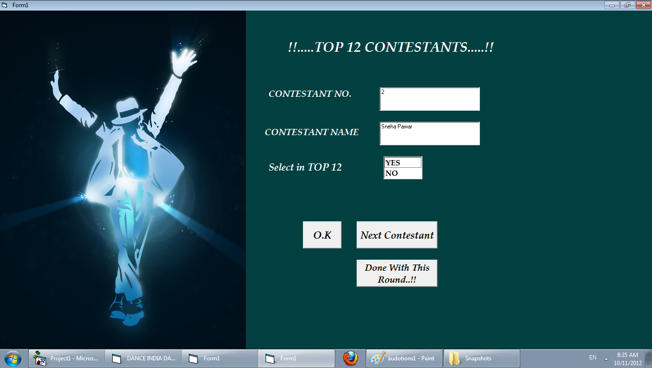



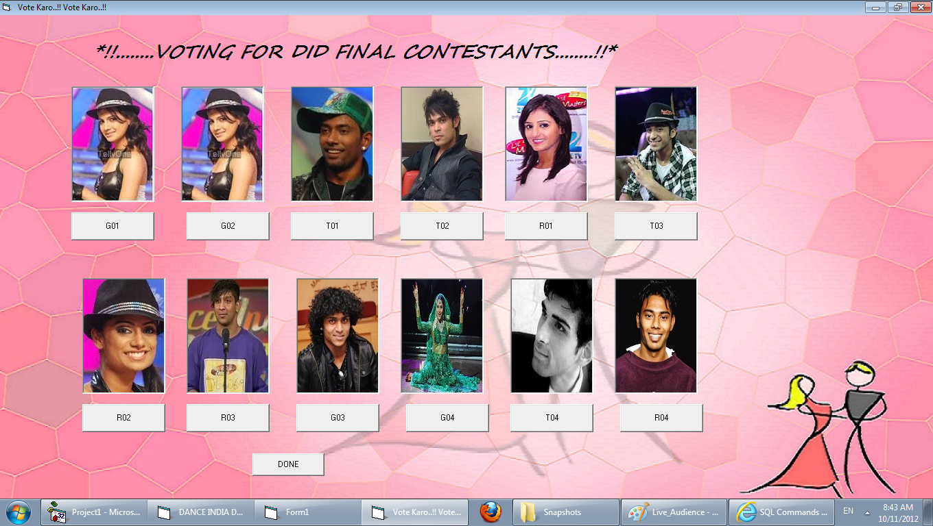

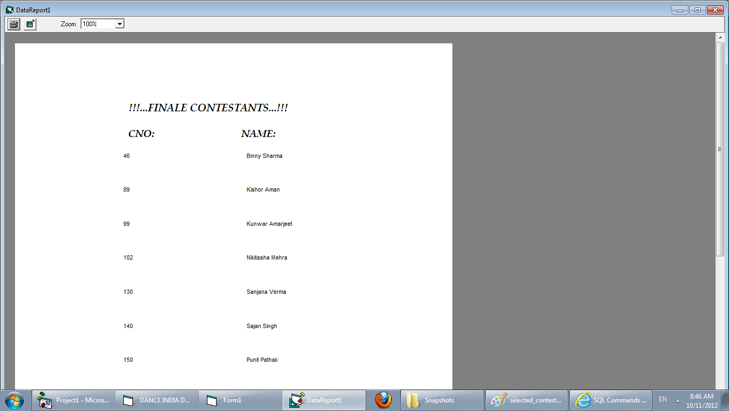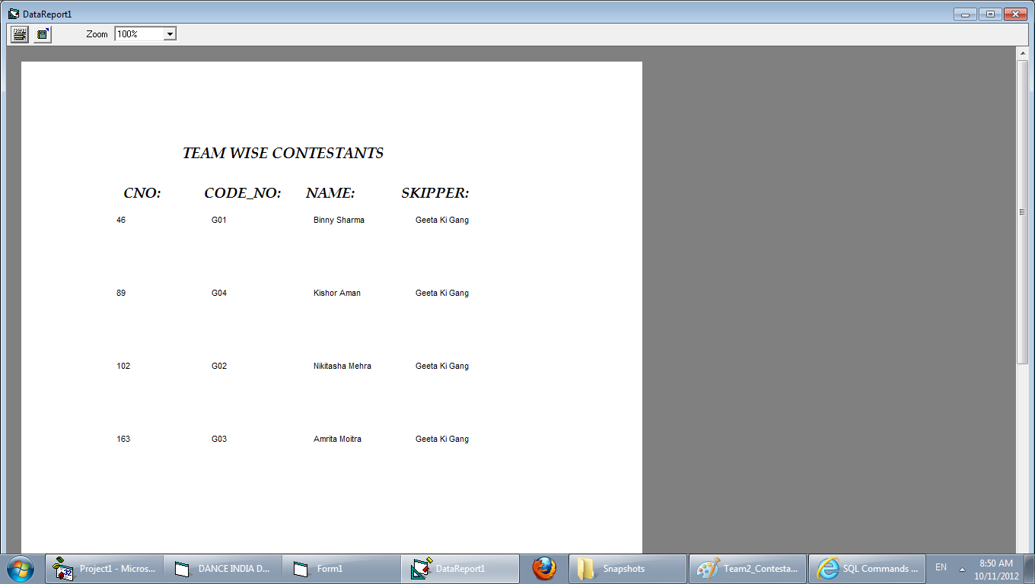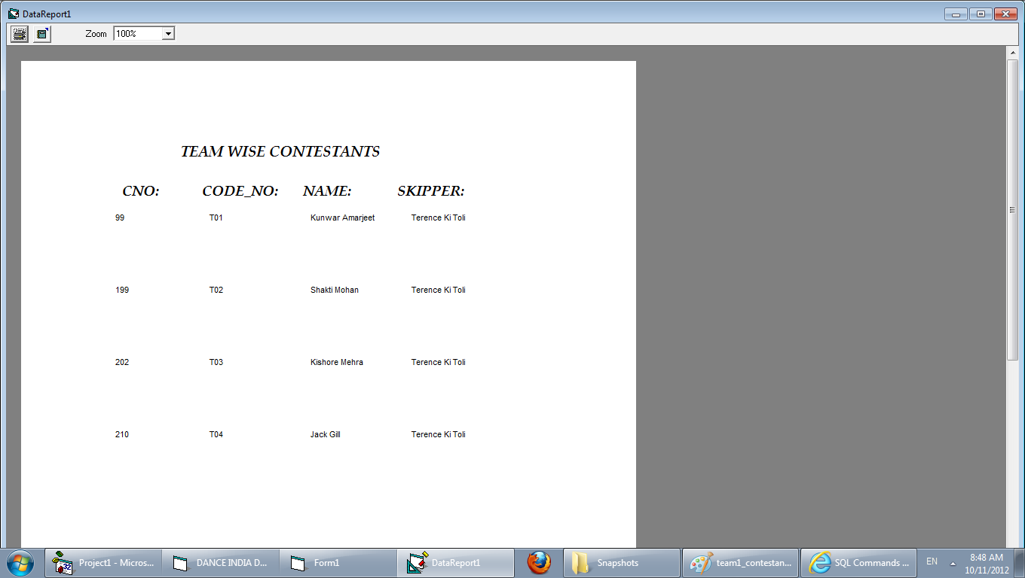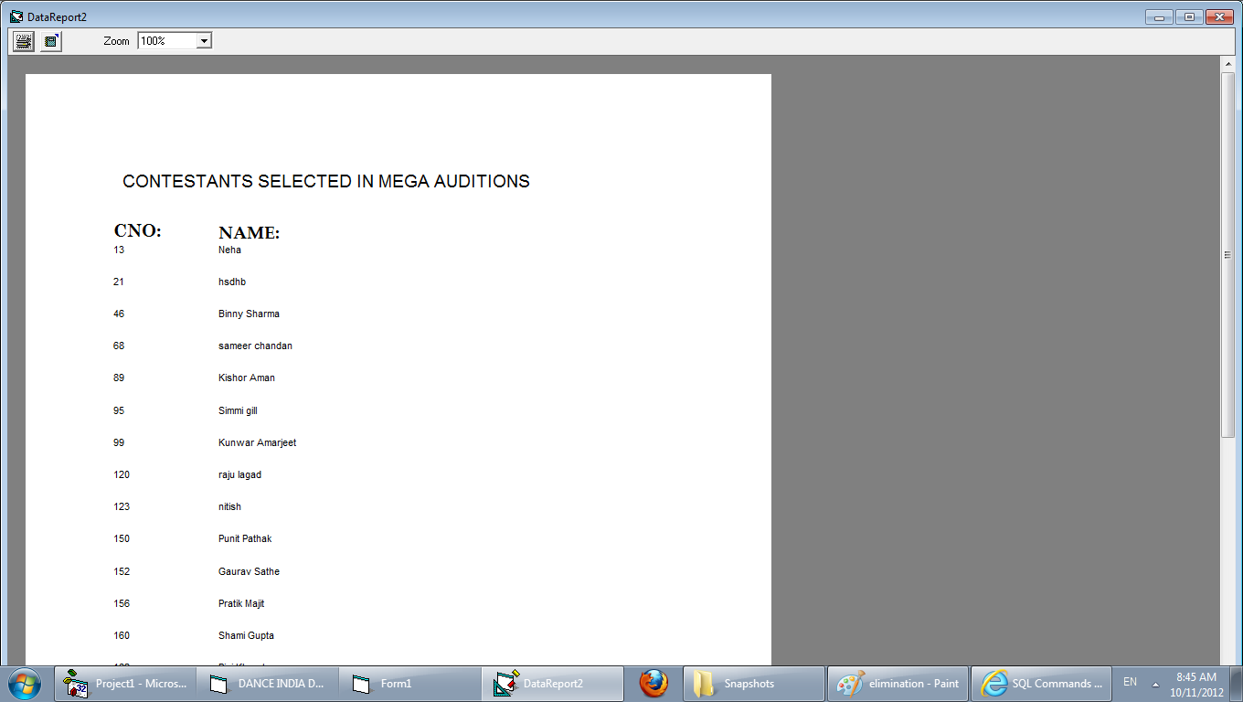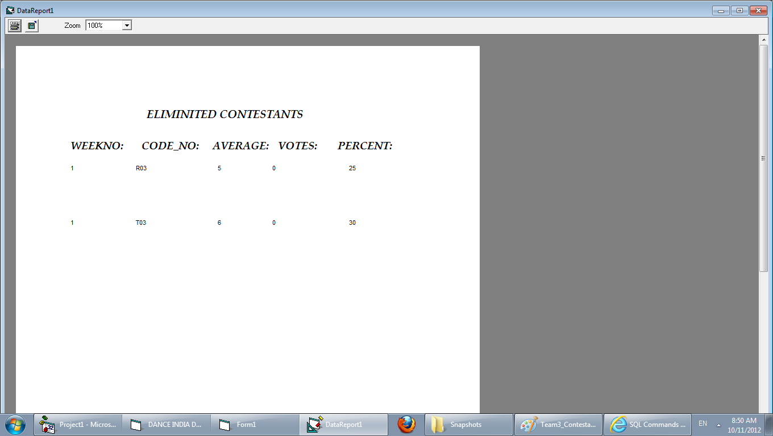

# CONCLUSION

The three parts which are essential for this project are User interface, Creation of relational database and SQL engine.

The Project is entirely based on database management system concepts. The back-end use for project is MySql and front-end is PHP and Java. The Coding of Sql queries through PHP AND Java is properly done. The project is very feasible.

The software engineering concepts are used to implement the project. The requirement analysis is understood and done for this project.